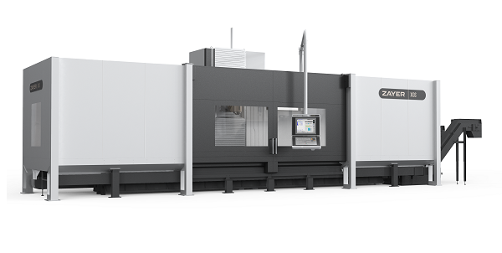
床型 / BED TYPE

XIOS 3000
www.zayer.com

工作尺寸 / WORKING DIMENSIONS
工作台面  Table surface | 3.000 x 1.000 | mm
纵向行程  Longitudinal travel | 3.000 | mm
横向行程  Cross travel | 1.200 | mm
垂直向行程  Vertical travel | 1.200 | mm
工作台到主轴鼻端最小最大距离  Max. distance from table to spindle nose | 1.145 | mm
直线轴承载力 / CAPACITY OF LINEAR AXES
快速进给 （纵轴）  Rapid feed (longitudinal axis) | 30.000 | mm/min
快速进给 （横轴和垂直轴）  Rapid feed (cross and vertical axis) | 35.000 | mm/min
工作进给（纵轴）  Working feed (longitudinal axis) | 25.000 | mm/min
工作进给（横轴和垂直轴）  Working feed (cross and vertical axis) | 30.000 | mm/min
驱动 / Drives:
. 纵轴  . Longitudinal axis | 双电机齿条齿轮  Rack and double motor and pinion
. 横轴和垂直轴  . Cross and vertical axis | 滚珠丝杠 / Ball screw
CNC
HEIDENHAIN TNC 640 + HR 510

头  HEAD | 附件  EQUIPMENT
45º自动头360000个位置0.001分度  45º, 360.000 positions  功率 40 kW  Power  主轴头速度 6000 rmin⁻¹  Speed of the spindle head | 刀库 30  Tool magazine  冷却设备 22+5 bar, 1000 l  Coolant equipment  2 排削器  2 goose neck chip conveyors  完整的外壳顶部打开  Complete enclosure open on top  APPs: Center Table  Dynamic Selection  Virtual Tool Orientation  ZAYER REMOTE SERVICE

